March 21st, 2010
Hi
I am starting this letter at the same time as I was finishing my run yesterday as I sleep in for a while on Sunday mornings. Again very warm and humid for the run. At 2 h 19 min, it was 6 min faster than last year, though for a lot of last year’s run I was running through heavy rain (not so bad) while dodging thunder bolts (not so good). Also, much more flat running for this run. This may be the last run of the season at least in HK as I fly out next Sunday. I am taking my running gear with me and hope to do a few runs and hikes in NZ.
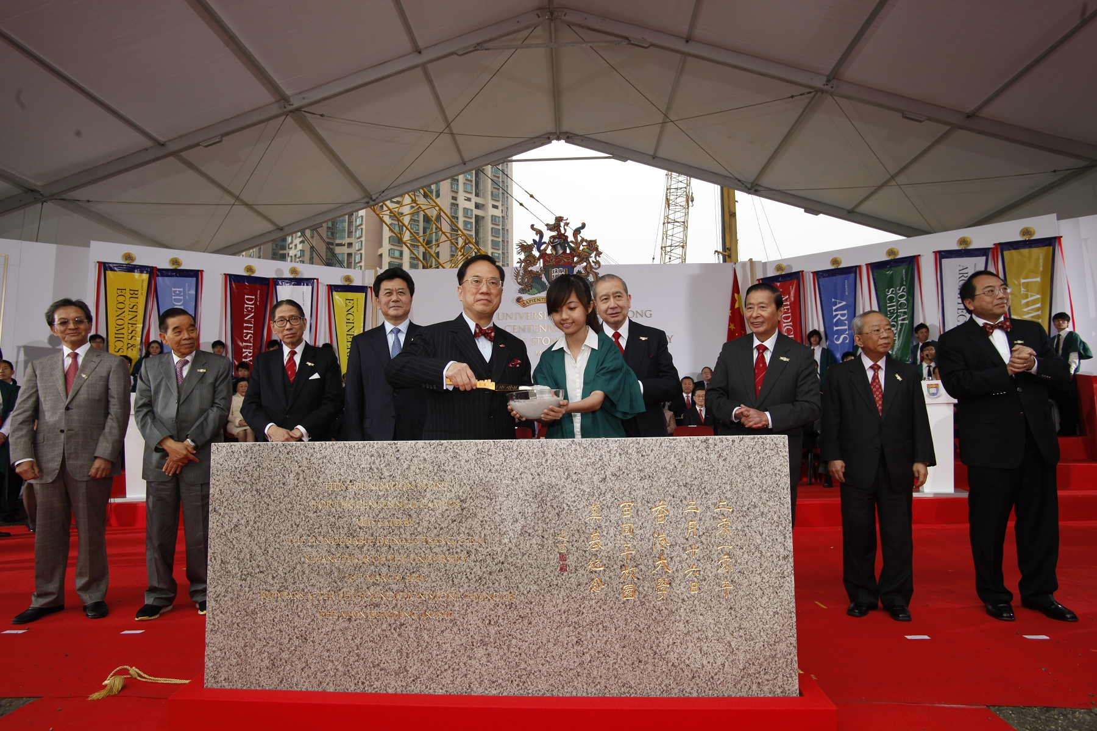
Last Wednesday was the 100th year of the laying of the foundation stone for HKU. A bit ceremony was held at which another inauguration stone was laid for another large new building by the CE. And talking of universities in HK, Condoleezza Rice is at in HK at CUHK where she is attending some conference and, of course, giving speeches.
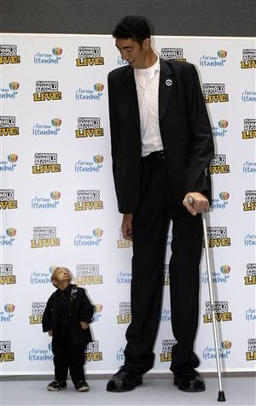
Saw on TV that the shortest man in the world (~74 cm) died in Rome, aged just 21. He is from China (Inner Mongolia) but was in Rome to appear on a TV show. I wonder how he felt about appearing on TV shows and in advertisements for people to gawk at? Seems to be little different from the ‘freak shows’ that used to be held in previous centuries.
Have been busy for several days of the week proofreading a lower secondary science revision book for the Singapore publisher.

Next weekend, the Rugby 7s will be in HK. As I wrote in last year’s letter, for the past few Saturday evenings, TVB has been showing highlights from the 7s tournaments held so far this season. The European ‘Six Nations’ ended yesterday with France just beating England to take the ‘Grand Slam’ (winning all their games).
That’s seems to be all for now. Will try to write a note next Saturday before leaving here on Sunday morning.

Cheers.

